1. 性能测试（10人）

1.测试总览

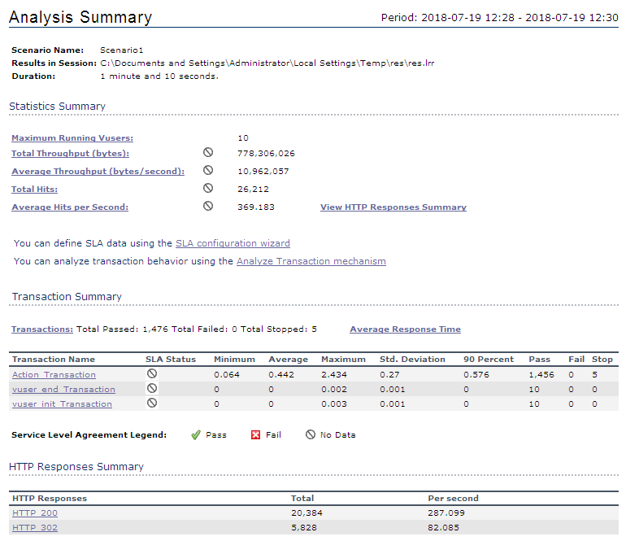

2.每秒点击量

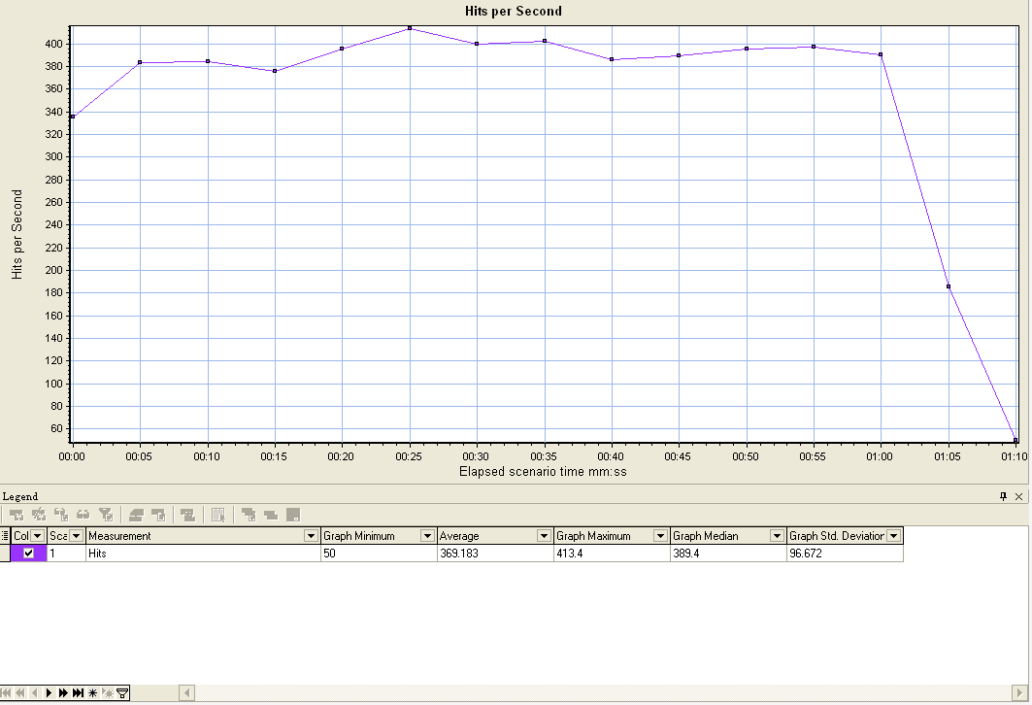

3.吞吐量

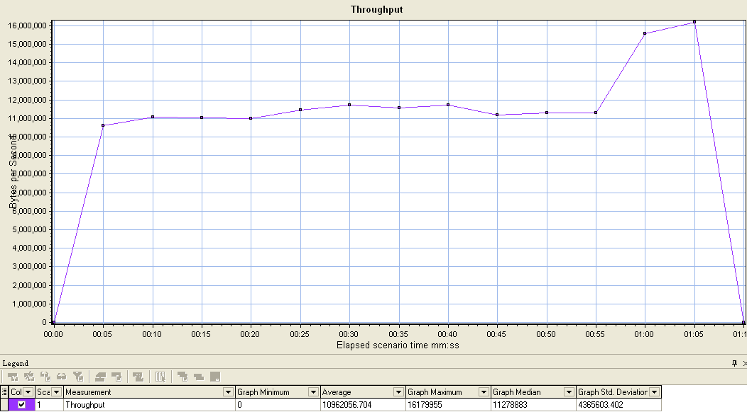

4.事务总览

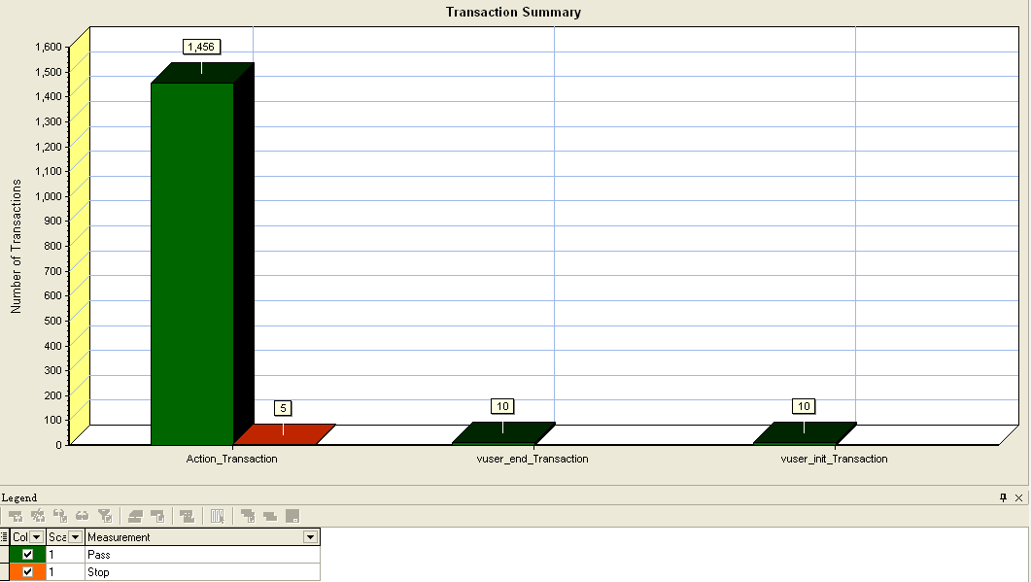

5.平均响应时间

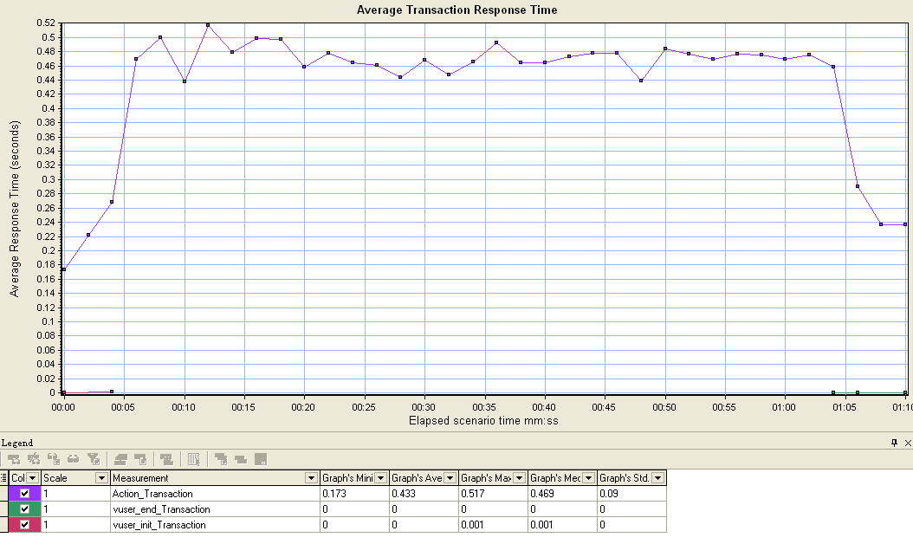

1. 性能测试（100人）

1.测试总览

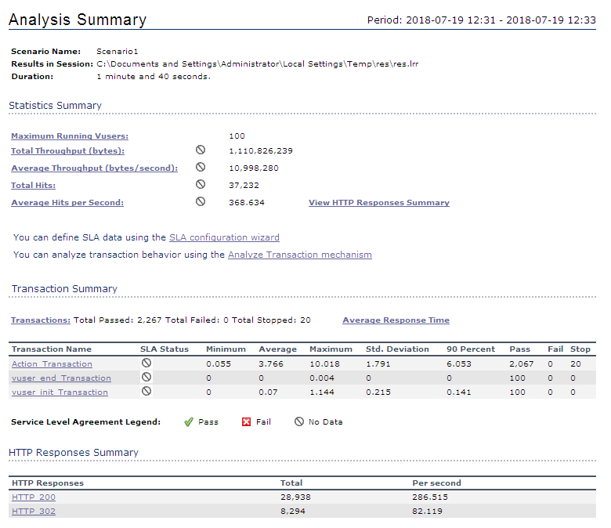

2.每秒点击量

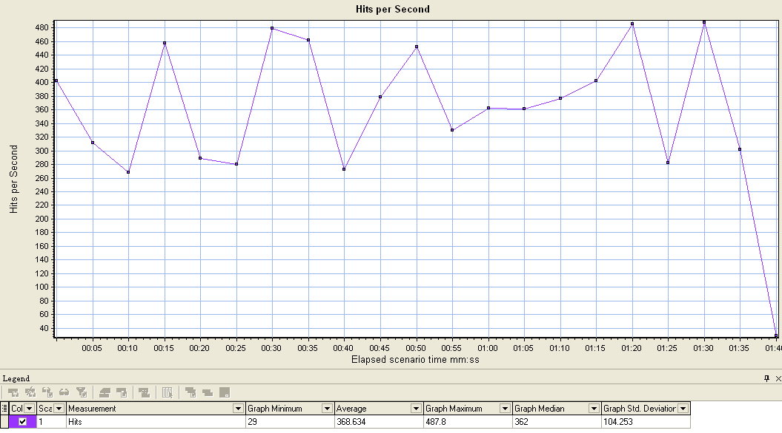

3.吞吐量

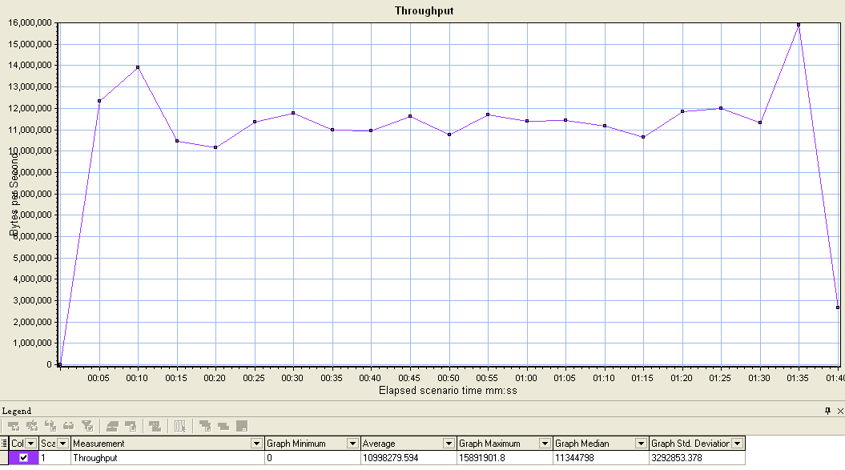

4.事务总览

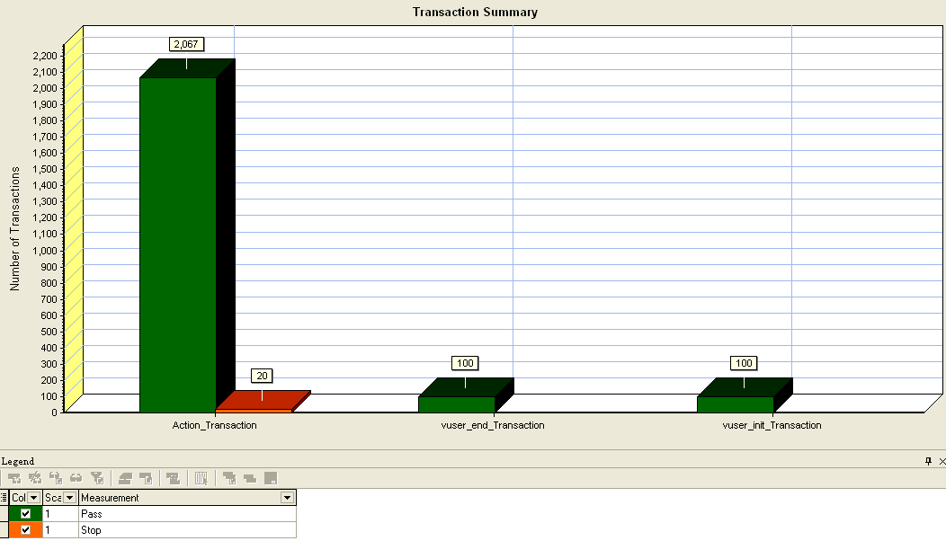

5.平均响应时间

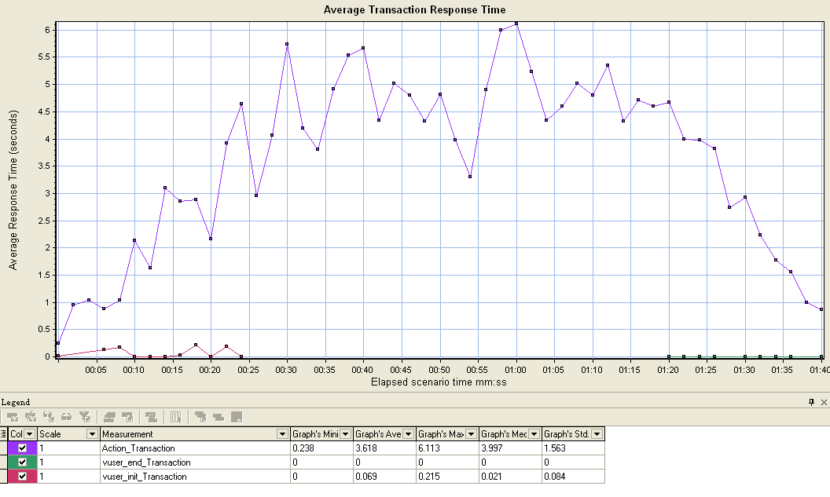

1. 性能测试（500人）

1.测试总览

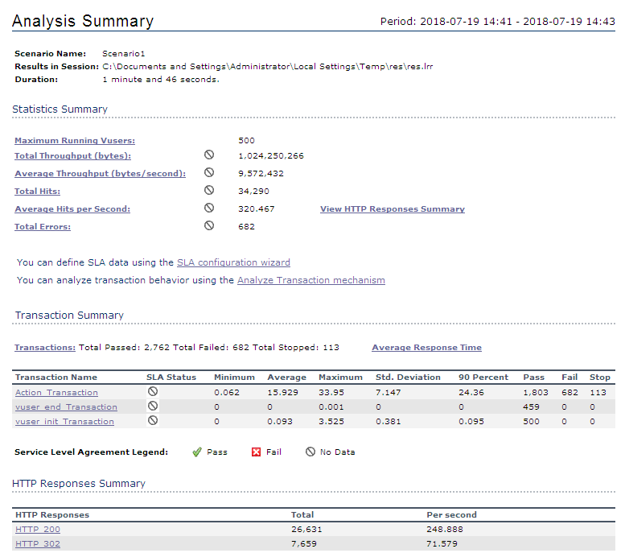

2.每秒点击量

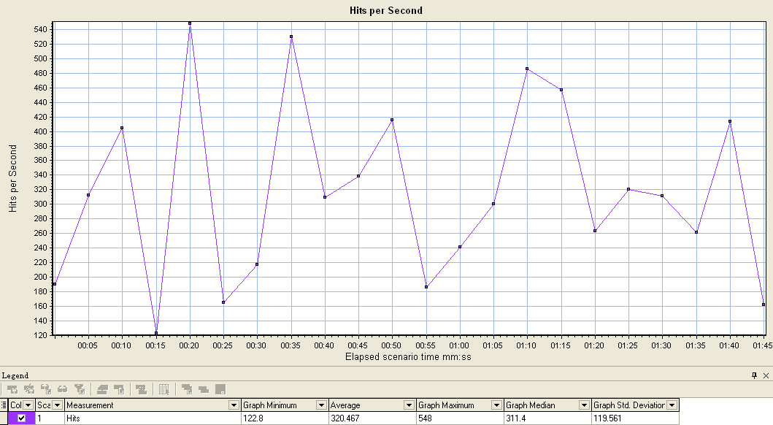

3.吞吐量

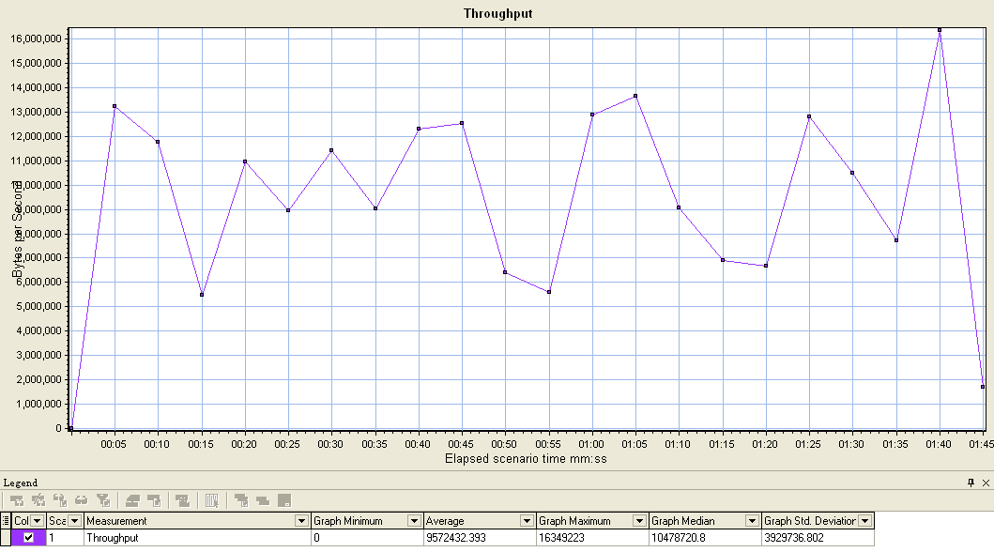

4.事务总览

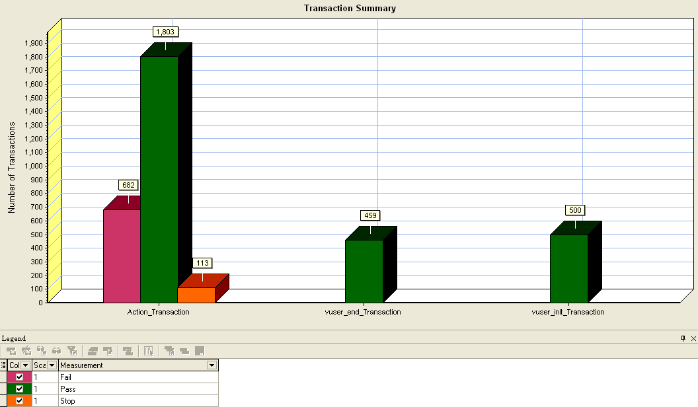

5.平均响应时间

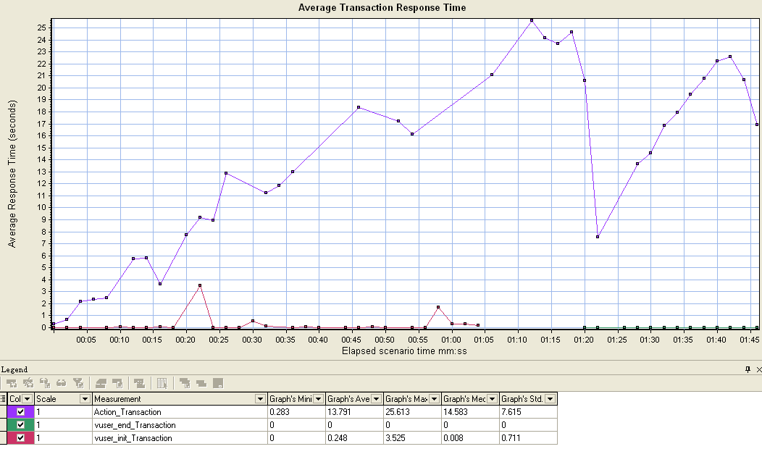

附.测试脚本代码

Action()

{

web_submit_data("login",

"Action=http://127.0.0.1:8080/renren-admin/sys/login",

"Method=POST",

"TargetFrame=",

"RecContentType=application/json",

"Referer=http://127.0.0.1:8080/renren-admin/login.html",

"Snapshot=t4.inf",

"Mode=HTML",

ITEMDATA,

"Name=username", "Value=admin", ENDITEM,

"Name=password", "Value=admin", ENDITEM,

"Name=captcha", "Value=", ENDITEM,

LAST);

web_add_cookie("monitor_count=5; DOMAIN=127.0.0.1");

web_url("index.html",

"URL=http://127.0.0.1:8080/renren-admin/index.html",

"TargetFrame=",

"Resource=0",

"RecContentType=text/html",

"Referer=http://127.0.0.1:8080/renren-admin/login.html",

"Snapshot=t5.inf",

"Mode=HTML",

EXTRARES,

"Url=sys/user/info?_1531971601754", ENDITEM,

"Url=sys/menu/nav?_1531971601752", ENDITEM,

LAST);

web_url("main.html",

"URL=http://127.0.0.1:8080/renren-admin/main.html",

"TargetFrame=",

"Resource=0",

"RecContentType=text/html",

"Referer=http://127.0.0.1:8080/renren-admin/index.html",

"Snapshot=t6.inf",

"Mode=HTML",

LAST);

return 0;

}